Finger print
Tittle: Secure fingerprint matching system
Topics:
- python image processing, fingerprint matching algorithm, if-else logic, error handling, multithreading, FIFO/LIFO-data structures, SQL --DDL/DML, python- SQL integration, database query& security
Problem Statement: My scenario is I would like to print a green button if my
thumb is available in the database are print red button
Role/Responsibilities:

- Python code:
  - Syntax:
    - Thumb-id=input(“place your thumb(enter your thumb-id:)”)
    - Database=[“thumb-1”,”thumb-2”,thumb-3”]
    - If thumbed in database:
      - Print(“green button: your thumb is available”)
    - Else
      - Print(“red button: your thumb is not available”)
  - Real time code:
    - Fingerprint database creation
    - fingerprint_db = ["FP101", "FP102", "FP103"]
      - # Database lo store chesina fingerprints list
    - def authenticate_fingerprint(fp_id):
      - # Fingerprint authenticate cheyyadaniki function
    - try:
      - # Error handle cheyyadaniki try block
    - print("Scanning Fingerprint...")
      - # Fingerprint scan start message
    - if fp_id in fingerprint_db:
      - # Fingerprint database lo unda check
    - print("Fingerprint Found in Database")
      - # Fingerprint match ayyindi
    - print("ACCESS GRANTED ✔")
      - # Green signal – access allow
    - else:
      - # Fingerprint match kakapothe
    - print("Fingerprint NOT Found in Database")
      - # Fingerprint dorakaledu
    - print("ACCESS DENIED ✖")
      - # Red signal – access deny

    - except Exception as e:
      - # Runtime error vasthe
    - print("System Error:", e)
      - # Error message display
    - # ================= Test Scenarios =================
    - authenticate_fingerprint("FP101")
      - # Valid fingerprint test case

    - print("-----------------------------")
      - # Output separation line

    - authenticate_fingerprint("FP999")
      - # Invalid
    - fingerprint test case
  - Output:
    - Scanning Fingerprint...
    - Fingerprint Found in Database
    - ACCESS GRANTED ✔
    - -----------------------------
    - Scanning Fingerprint...
    - Fingerprint NOT Found in Database
    - ACCESS DENIED ✖

- Diagram:
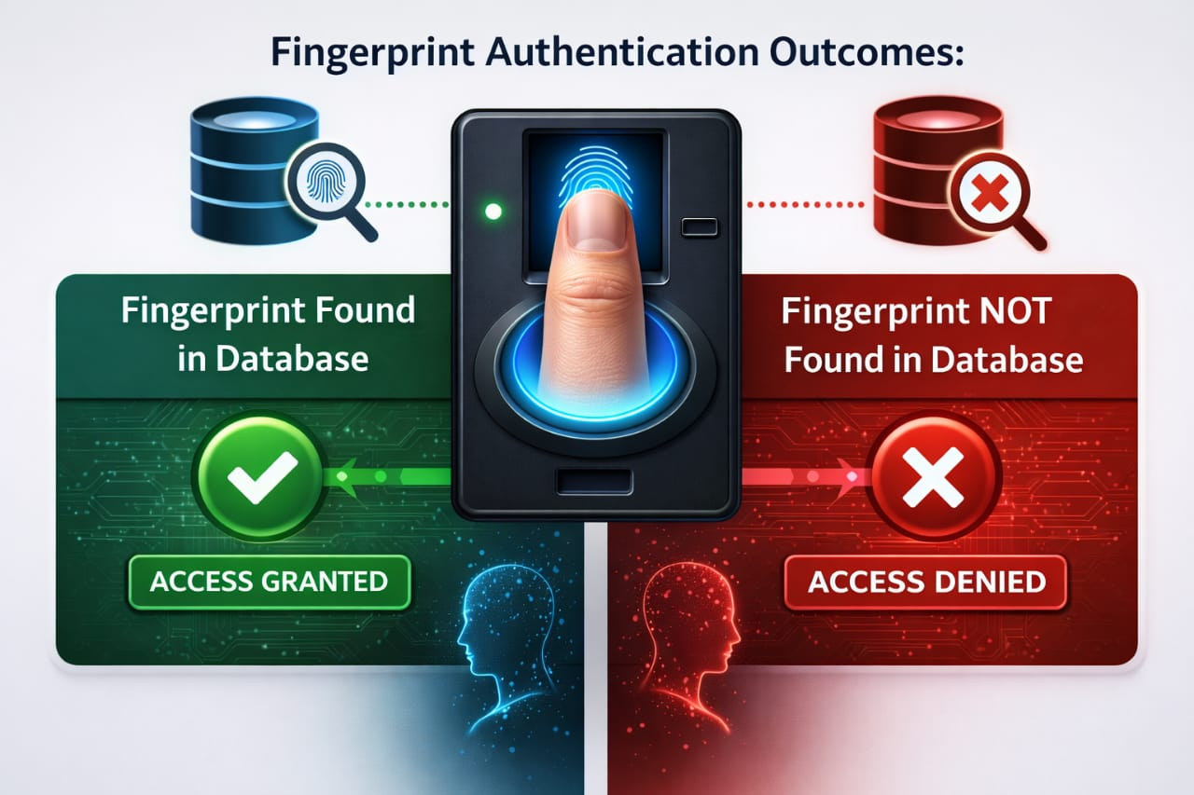
Interview Questions:
- Explain your finger print project in 3 lines
  - Authentication
- What is fingerprint matching logic
  - Comparison
- Which python/SQL topics did you use
  - Integration
- Why use multithreading in this project
  - Performance
- What is FIFO/LIFO use here
  - Sequencing
- How did you handle errors
  - Exception
- Purpose of green/red button
  - Authorization
- What database is used
  - SQL

